HIGH-PERFORMANCE UNIFIED POWER QUALITY CONDITIONER USING NON-LINEAR SLIDING MODE AND NEW SWITCHING DYNAMICS CONTROL STRATEGY
ABSTRACT
In this study, a non-linear sliding mode control (NLSMC) and new switching dynamics control strategy have been proposed for a unified power quality conditioner (UPQC) to improve the power quality problem in power system distribution network. The proposed non-linear sliding surface reflects the controlling action of the DC-link capacitor voltage with a variation of the system's damping ratio and permits the DC-link voltage to obtain a low overshoot and small settling time. This NLSMC technique combines with a novel synchronous-reference frame (SRF) control technique for generation of a rapid and stable reference signal for both shunt and series converters. A new switching dynamics control strategy has been designed for the voltage source converters of UPQC and this design helps in the reduction of band violation of the hysteresis band as well as improvement in the tracking behaviour of UPQC during grid perturbations. Consequently, NLSMC-SRF technique along with new switching strategy in UPQC provides an effective compensator for voltage/current harmonics, sag/swell, voltage unbalance and interruptions. The proposed control strategy of UPQC is validated through MATLAB/SIMULINK, followed by the experimental system using real-time hardware-in-the-loop. Adequate results are reported after a comparative assessment with the conventional proportional–integral and hysteresis controller.

BLOCK DIAGRAM FOR PROPOSED SYSTEM
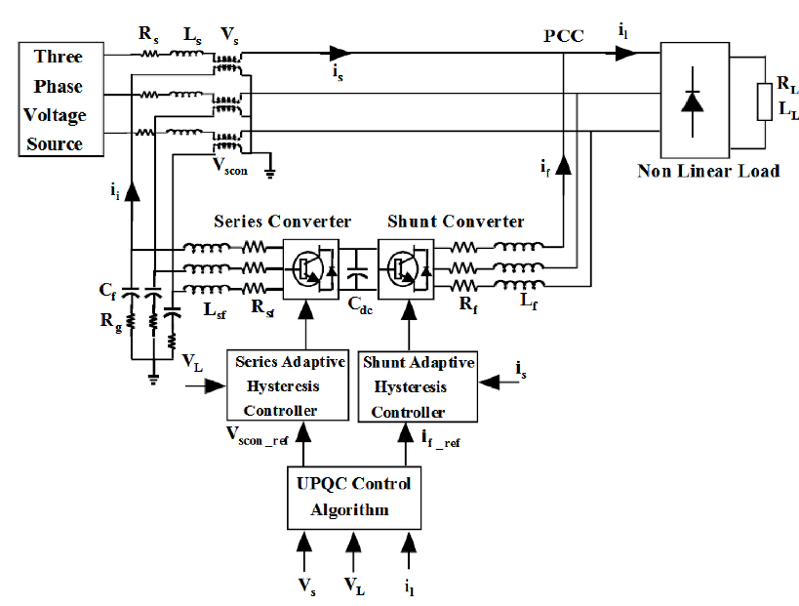
Fig. 1 System configuration and response of UPQC
DESIGNG SOFTWARE AND TOOLS:
MAT LAB /SIMULATION Software and simu power systems tools are used. Mainly control system tools, power electronics and electrical elements tools are used.

